mmWave Radar Report

Millimetre wave radar uses short electromagnetic wavelengths in order to discern range, velocity and angle of arrival of objects present in the radar’s line of sight. The short wavelengths used by the radar possess the advantages of high accuracy, being able to detect movements as small as a fraction of a millimetre and small antenna size which results in a small compact radar system.

This report will focus specifically on millimetre-wave radar sensors produced by TI (Texas Instruments). TI have integrated almost the entire radar system on a single CMOS package whereas previous systems used discrete components which resulted in higher power consumption and manufacturing costs. Also, in difference to previous systems the TI system uses frequency modulated continuous wave (FMCW) technology which differs from traditional radar systems which transmit short periodic pulses.

The FMCW radar transmits a signal known as a chirp. A chirp is a sinusoidal signal whose frequency increases linearly with time. An amplitude time plot of a chirp signal can be seen in Figure 1.

Figure 1

The same chirp signal can also be represented by a frequency time plot. The key parameters that describe the chirp are the bandwidth(B), the start frequency(fc), and duration (Tc). These parameters are very important in regard to the FMCW radar system as they play a key part in characterising traits of the system such as range resolution, maximum range, velocity resolution etc.

Figure 3 is an overview of the radio frequency (RF) components of the radar. The synthesiser sometimes referred to as the local oscillator generates a chirp signal, this signal is then transmitted by the transmit (TX) antenna of the system. The receive (RX) antenna of the system will then pick up any reflections of the transmitted chirp. Any reflected chirp signals and the original signal generated by the synth are both fed into a mixer which produces an intermediate frequency (IF) signal.

Figure 3

Two input sinusoids X1 and X2 when fed into the mixer produce a signal characterised by the Xout equation, where the instantaneous frequency is the difference of the instantaneous frequency of the two input sinusoids and the phase is equal to the difference of the phases of the two input sinusoids.

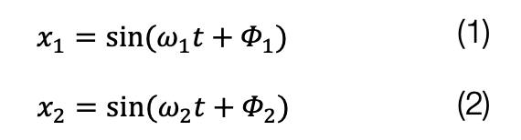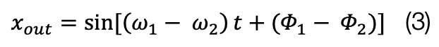

The time delay between the instant the transmitted chirp begins and the instant that the reflected chirp signal begins to be received by the RX antenna can be expressed mathematically as stated below in equation 4.

Time delay = 2 x distance between radar and object

The speed of light

Figure 4 shows frequency time graphs indicative of what you would see at the mixer’s inputs and output. The upper graph shows the chirp signals present at the transmitter and receiver, whilst the lower graph shows the IF signal found at the output. The IF signal is a constant frequency sinusoid (sine wave) which is valid between the start of the received chirp and the end of the transmitted chirp. The frequency of the IF signal can be found by subtracting the frequency of the received chirp from the frequency of the transmitted chirp at any time instant between the start of the received chirp and end of the transmitted chirp.

Figure 4

The initial phase of the IF signal is the difference between the initial phases of the TX chirp and the RX chirp. This initial phase of the IF signal can be written as

or

The IF signal as a whole can be characterised by the equation

Figure 5

The radar can detect multiple objects at varying distances. Figure 5 shows 3 reflected chirps for objects at 3 different distances away from the radar. The 3 different received chirps create 3 different IF frequency components which can be extracted using the Fourier transform.

Range resolution is the difference in distance from the radar necessary between two objects in order for them to be identifiable as two separate objects. We can use the two properties below to derive an equation for the range resolution of the radar.

An object at distance d has a IF tone frequency of

And two tones can be resolved in the frequency domain as long as

– S2d2/C > 1/Tc

S2d1 – S2d2 > C/Tc

d1 – d2 > C/2STc

Δd > C/2STc

Δd > C/2B

Dres = C/2B

The range resolution of the radar turns out to be dependent on the bandwidth.

Figure 6

Velocity and angle measurements can be calculated by exploiting the fact that small distance changes can easily be measured by inspecting the phase of the IF signal.

First let’s explore velocity measurement. Velocity of a single object can be calculated by transmitting two chirps as seen in figure 6 and then processing the 2 received chirps through a range Fourier transform as seen in the bottom of figure 6 and then comparing the phase difference between the two almost identical peaks.

The phase difference can be calculated as and the velocity as a result can be calculated as . As the velocity is calculated using a phasor there can be ambiguity if or 180°.

Figure 7

Figure 7 of a phasor can help explain this ambiguity. If we accept values of Φ over 180° we cannot be sure if we are in situation A where the object would be moving towards the radar or situation B where the object would be moving away from the radar, each of which would occur at different velocities.

With this restriction in mind, we can unambiguously measure velocities without further information so long as the velocity fulfils the inequality Following this the max velocity the radar can detect be described by

.

Using only two chirps is sufficient to measure the velocities of objects being observed at different distances from the radar however if this is not the case and multiple objects are equidistance from the radar the reflected waves will produce identical IF frequencies. We can remedy this by sending several chirps known as a chirp frame. Figure 8 shows a frequency time graph of a typical chirp frame consisting of N chirps all spaced an equal Tc apart. We then can put the resultant IF signals from the chirps through a range Fourier transform which will produce identical peaks with differing phases as seen in figure 9. We can then process these differing phase angles through a doppler FFT to resolve the separate ω

Figure 9

Figure 8

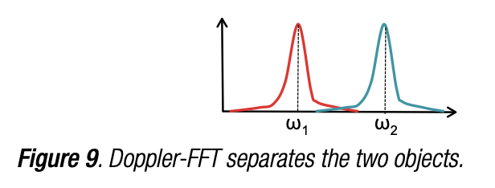 values (as seen in figure 10) which we can then use to calculate the velocities of the objects in question. Using the equation below. This application of a Range FFT followed by a Doppler FFT is often referred to as a 2D FFT.

Figure 10

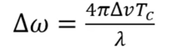Velocity resolution refers to the minimum difference in the velocity of two objects for the velocities to show as two separate peaks in the doppler FFT. We can calculate the velocity resolution of the radar using the fact and that on an N length sequence the FFT can separate angular frequencies whose separation satisfies the inequality A picture containing icon

Frame time (Tf)

From the above we can see that the velocity resolution is inversely proportional to the frame time and can be described by the Vres equation above.

With what has been covered so far, we can design a chirp frame in order to meet certain requirements. By rearranging the equation, we have derived so far, we get the following equations as seen on the right. These equations depend on many of the key parameters highlighted at the start of this report. However, these equations don’t paint the full picture regarding achieving a set of desired criteria. The hardware may limit certain parameters such as the maximum bandwidth, the slope we can use and how many samples we can take. We also may be limited by the RF properties of the device following the radar range equation and having to meet certain SNR requirements.

We can also determine the angle of objects relative to the radar in the horizontal plane. This angle is referred to as the angle of arrival and is described in figure 11.

Figure 11

Angle estimation requires at least two RX antennas.

Figure 12

We assume that the distance from the radar to the object is large enough in relation to the small distance between the antenna that we can assume the lines of incidents d and d+△d are parallel then using this assumption apply basic geometry and derive the relationship set out below

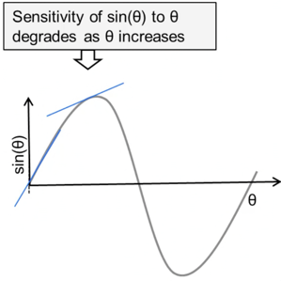

Figure 13

The relationship between ω and θ depends on the sine function which is non-linear this means the sensitivity changes depending on the angle of arrival θ. A visual representation of this non-linear dependency can be seen in figure 13.

In a similar manner to velocity measurements there is a limit to the ω value of pi in order to keep our angle estimate from being ambiguous. Below derives an equation to work out the angular field of view of the radar.

From this we can see that an antenna spacing of λ/2 results in the largest field of view.

To calculate the angles of two equidistant objects approaching at the same relative speed to the radar we can't apply the technique explored before as the phasors will have contributions from both objects we can’t separate. In order to solve this issue, we introduce more RX antennas into our radar. By adding more antennas, we can perform the 2D FFT on a larger data set which will provide more phases from the peaks creating a discrete series of two rotating phasors which we can then apply the Fourier transform to separate the rates of rotation. This process is described visually in figure 14.

Figure 14

The angular resolution of this method referring to the smallest angle difference between two objects theta can take whilst still producing distinct peaks in the angular FFT is given by the equation.